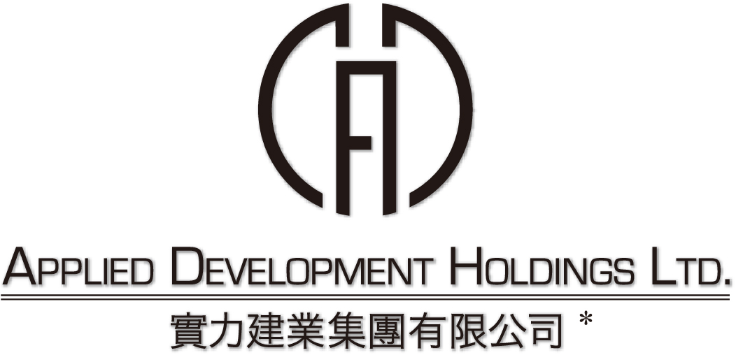
(incorporated in Bermuda with limited liability)
(Stock code: 519)

NOTIFICATION OF BOARD MEETING

The board of directors (the “Board”) of Applied Development Holdings Limited (the “Company”) hereby announces that a meeting of the Board will be held on Monday, 13 October 2008 at 10:15 a.m. for the purpose of, among other matters, approving the release of the final results announcement of the Company and its subsidiaries for the year ended 30 June 2008 and considering the payment of a final dividend, if applicable.

On behalf of the Board
Applied Development Holdings Limited
Ng Kit Ling
Company Secretary

Hong Kong, 19 September 2008

As at the date of this announcement, the Board comprises Messrs. Hung Kin Sang, Raymond, Hung Wong Kar Gee, Mimi, Fang Chin Ping and Hung Kai Mau, Marcus as executive directors of the Company; and Messrs. Lo Yun Tai, Lun Tsan Kau and Lam Ka Wai, Graham as independent non-executive directors of the Company.

* For identification purposes only

