Hong Kong Exchanges and Clearing Limited and The Stock Exchange of Hong Kong Limited take no responsibility for the contents of this announcement, make no representation as to its accuracy or completeness and expressly disclaim any liability whatsoever for any loss however arising from or in reliance upon the whole or any part of the contents of this announcement.

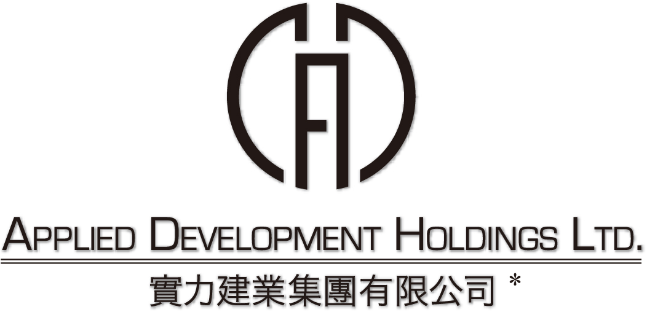
(incorporated in Bermuda with limited liability)
(Stock code: 519)

NOTIFICATION OF BOARD MEETING

The board of directors (the “Board”) of Applied Development Holdings Limited (the “Company”) hereby announces that a meeting of the Board will be held on Wednesday, 21 October 2009 at 11:30 a.m. for the purpose of, among other matters, approving the release of the final results announcement of the Company and its subsidiaries for the year ended 30 June 2009 and considering the payment of a final dividend, if applicable.

On behalf of the Board
Applied Development Holdings Limited
Ng Kit Ling
Company Secretary

Hong Kong, 6 October 2009

As at the date of this announcement, the Board comprises Messrs. Hung Kin Sang, Raymond, Hung Wong Kar Gee, Mimi, Hung Kai Mau, Marcus and Fang Chin Ping are executive directors of the Company; and Messrs. Lo Yun Tai, Lun Tsan Kau and Lam Ka Wai, Graham are independent non-executive directors of the Company.

* for identification purpose only

