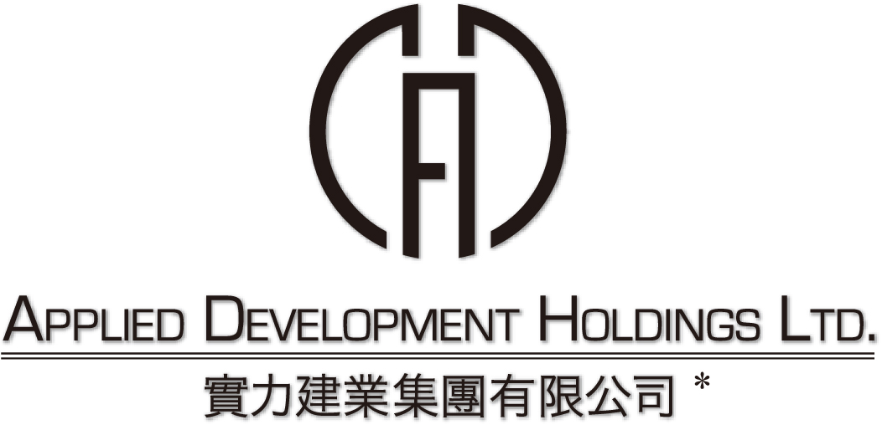
(incorporated in Bermuda with limited liability)
(Stock code: 519)

SUSPENSION OF TRADING

At the request of the Company, trading of the shares in the Company (Stock code: 519) will be suspended from 9:30 a.m. on 23 September 2009 pending the issue of an announcement regarding price sensitive information of the Company.

By order of the Board
Applied Development Holdings Limited
Hung Kin Sang, Raymond
Managing Director

Hong Kong, 23 September 2009

As at the date of this announcement, the Board comprises Mr. Hung Kin Sang, Raymond, Ms. Hung Wong Kar Gee, Mimi, Mr. Hung Kai Mau, Marcus and Mr. Fang Chin Ping as executive directors; and Mr. Lo Yun Tai, Mr. Lun Tsan Kau and Mr. Lam Ka Wai, Graham as independent non-executive directors.

* for identification purpose only

